**The Environmental Costs of Fracking**

*By: Sage Dewdney*

*HSA 10 The Economics of Oil and Energy*

*April 7, 2016*

**Background**

Crude oil is one of the most important commodities in the modern world. Over 7.81 billion barrels of petroleum products are consumed in a year the US.[1] The vast majority of vehicles run on crude oil products, and petroleum products are also used for heating, electricity generation, asphalt production, and plastic synthesis. Petroleum products are the largest contributor to US energy consumption, regardless of cost: in 2012 energy from crude oil cost over 21.56 cents per kilowatt-hour to produce.[2] Now, that price is significantly lower at 6.63 cents per kilowatt-hour.[3] Further, the stock market and the global economy are strongly tied to the price of crude oil.[4] In short, most of our daily lives are dependent upon this limited resource in some way. In more recent times, a new method of acquiring crude oil called fracking is gaining popularity. It offers several distinct advantages; prominent among them fracking allows large previously untapped deposits of oil to be mined. The increase development and implementation of fracking technology could raise the US GDP by 4%.[5]

The ability to access huge deposits of oil and natural gas via fracking offers a huge opportunity in the US to decrease energy costs by significantly increasing the availability of crude oil. Not only is a lot more crude oil available due to fracking, it is excellent fracking sites exist throughout the US which allows for a local supply. While supply and demand are the main driving forces in the price of crude oil, mining the oil is also a major production cost. As seen in figure 1 above, the breakeven price for most oil fields in the US is around $30 per barrel. However, the production of crude oil carries other costs as well. In the US, fracking is often noted as being a relatively low cost way to 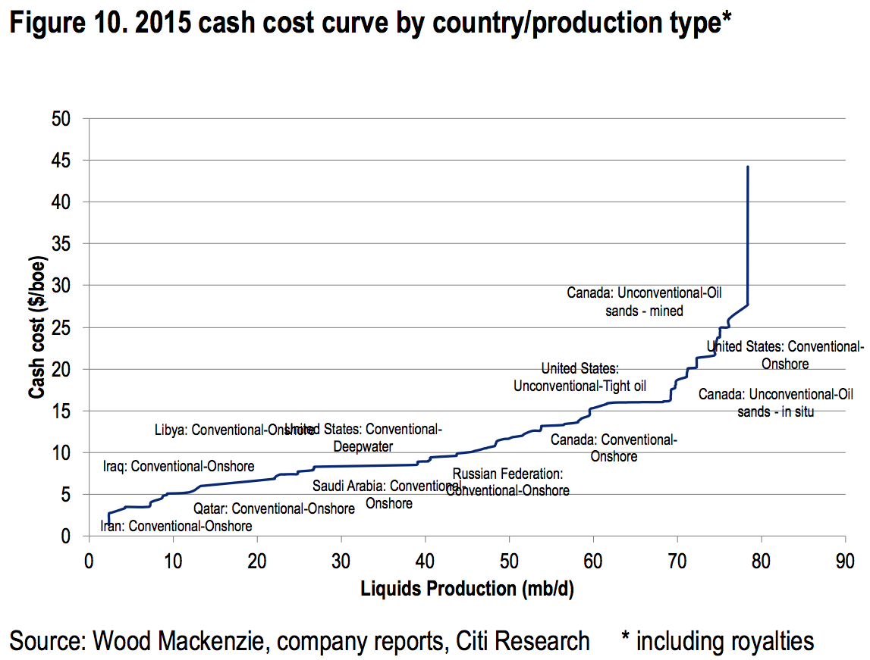obtain oil locally, but there are other costs associated with fracking that are often left unaccounted for. The environmental costs of crude oil fracking include: climate change, damage to natural resources, drinking water contamination, seismic activity, health problems, public infrastructure damage and property devaluation.

Figure

First, consider how the process of fracking works: far underground there are rocks called shale which hold gases, water, and oil in their pores. A long vertical well is drilled, then horizontal “veins” are created and pumped full of water and chemical additives to create an area of extremely high pressure. This pressure creates cracks in the shale like those seen in figure 2 below which releases gas, oil and water that are then forced back up to the surface where they can be processed and separated into storage tanks.[6] Compared to the traditional methods of crude oil mining where a long hole is drilled onto the earth, and a steel pipe with pressure valves is installed into the hole to pump oil out of a reservoir; fracking is an extremely powerful process capable of extracting oil from previously unreachable areas.

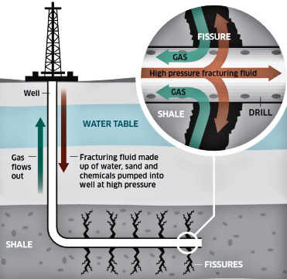

Figure 2

There are several environmental issues associated with fracking and estimating their cost to the environment can be challenging, so this paper will attempt to address major costs and risks associated with fracking while offering cost estimates where available.

**I. Climate Change**

Climate change is one of the biggest issues of our time, and energy companies often hail fracking as an eco friendly process since it often produces natural gas, which burns cleaner than other common fuel sources like coal. However, there are other issues associated with the process of fracking that may make fracking and the energy sources yielded by it much worse for the environment than those sources from traditional means. Fracking contributes to environmental damage by releasing large amounts of methane, a greenhouse gas, into the air. Methane gas makes up over 90% of shale gas and recent studies suggest that a considerable portion of this gas leaks during fracking.[7]

In fact, according to a report funded by the Environmental Defense Fund, the amount of methane gas leaked during a typical fracking operation may make oil and natural gas more environmentally damaging than coal.[8]

Not everything about crude oil fracking is negatively impactful to the environment. One significant benefit of shale oil production is that it could displace around 40% of waterborne crude oil imports to the US.[9] By reducing the need to transport large quantities of oil, fracking can reduce the pollution generated by barges.

**II. Damage To The Natural Landscape**

Shale basins are often found near important natural resources and historically important sites. Such basins have already been targeted by Shell and Total near the Auca Mahuida natural protected wildlife area in Argentina, which places a major wildlife sanctuary at risk.

Indigenous communities have found issue with shale oil drilling in Russia, South Africa, Brazil and Argentina where their entire way of life has been disrupted often without consulting the indigenous people at all.[10]

**III. Water Contamination**

Many large shale oil basins have been identified under transboundary aquifers. These groundwater resources hidden below ground contain enough free water to provide safe, high quality drinking water for everyone for years from a single aquifer.[11] Many of the basins located under transboundary aquifers are found in areas where water is already scarce and companies hoping to drill through these aquifers risk contaminating or destroying water supplies used by millions of people.9

In countries like Mexico, “The majority of (…) shale basins overlap with areas that are already plagued with high levels of water stress” [12]Fracking not only endangers existing water supplies but also requires a lot of water to perform. Much of the water used during fracking is rendered undrinkable by the process. The US EPA estimates that in 2010, 140 billion gallons of water were used to mine just 30,000 active wells.[13] Considering the demands for water in areas like Mexico where water shortages have already led to violent confrontations the impact of fracking on water availability is a major consideration.

**IV. Health Problems**

Fracking also poses major health risks to those in the areas surrounding a site. Chemicals used in the liquid extraction of crude oil from shale rock have considerable detrimental effects on the health of those exposed to them. In Figure 3 on the next page from the Wyoming oil and gas conservation commission, you can see that many of the chemicals found in fracking fluid pose the risk of damage to sensory organs as well the respiratory, nervous, and gastrointestinal system.

Recently, a Stanford study on drinking water contamination in Wisconsin found strong evidence that nearby fracking was contaminating local water supplies with dangerous chemicals. In addition to Benzene levels 50 times higher than the maximum contaminant level for safe drinking water, the study also found high levels of methanol, isopropanol, and ethanol.

While risk of exposure via other means may seem low, several studies have shown dangerous levels of air pollution near fracking sites. According to the National Resources Defense council, oil and natural gas production has been connected to increased risk of birth defects and cancer.[14]

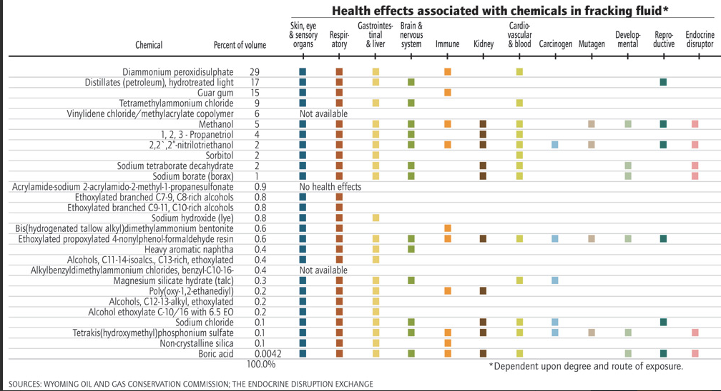

Figure 3

**V Infrastructure Damage**

Fracking operations can also wreak havoc on the surrounding infrastructure. Many operations are in undeveloped areas incapable of comfortably supporting the large increase in traffic associated with a fracking outfit. Transport of materials and equipment taxes local roads and railways heavily, and exporting the oil also imposes a significant demand on local infrastructure. A recent study on roadways in Pennsylvania found $23,000 dollars per fracking well in damages to major roads in the Marcellus Shale region.[15]

Another huge impact on local infrastructure is due to the increased seismic activity associated with drilling in these areas. The geology in shale basins can vary to an extreme degree making it very difficult to anticipate seismic impact. Since fracking has recently increased in China the region has experienced several uncharacteristic earthquakes in the last couple years. The US has observed multiple earthquakes over a 5 on the Richter scale due to fracking in previously seismically inactive areas, and seismic activity has also significantly increased in Mexico including deadly earthquakes that completely destroyed the local area.[16]

In a region of Ohio where no earthquakes had ever been recorded before fracking started, 77 separate earthquakes were found to be directly caused by nearby fracking between march 4th and 12th of 2014. Further, when that fracking operation closed, no more earthquakes have been observed.[17]

**Conclusion**

While fracking could be a major boon to both the US and global economy, the environmental impacts of this technology need to be given greater attention. When considering forms of energy production, the impact on the environment needs to be considered as well. Fracking endangers culturally important areas, places a major threat to water supplies, contributes to deforestation and a loss in biodiversity, causes health problems, contributes to climate change and may be responsible for lethal earthquakes. While the companies responsible for fracking activities are not paying this potentially huge cost, local communities are and such costs need to be accounted for when considering fracking as a viable alternative to obtain energy. Many modern energy alternatives like nuclear power are being dismissed as too risky to the surrounding environment, but traditional methods of energy production need to be examined with the same level of scrutiny.

[Word Count: 1762]

1. “EIA Frequently Asked Questions.” *Environmental Information Administration*. 2016. https://www.eia.gov/tools/faqs/faq.cfm?id=33&t=6.
2. Institute for Energy Research Energy Generating Costs
3. .176barrels of oil per kwh * $38 a barrel = 6.36
4. Stephen Gandel Stock Market Plunge Why Crude Oil Matters Fortune Magazine
5. PWC Shale Oil the Next Energy Revolution
6. Kate Kershner How Hydraulic Fracking Works
7. S Wrigley Research and Policy Recommendations for Hydraulic Fracturing and Shale-Gas Extraction
8. Alvareza,1,Jç, William L. Chameidesd, and Steven P. Hamburge, Ramón , Stephen Pacalab, William Chameidesd, and Steven Hamburg. “Greater Focus Needed on Methane Leakage from Natural Gas Infrastructure.” *Proceedings of the National Academy of Sciences of the United States of America*n.d., 2011.
9. PWC Shale Oil the Next Energy Revolution
10. Andy Gheorghiu Fracking Frenzy (2014)
11. Shammy Puri Internationally Shared Aquifer Resource Management
12. Sharon Kelly New Report Highlights Fracking’s Global Hazards
13. US EPA The Potential Impacts of Hydraulic Fracking on Water Contamination (2011)
14. National Resources Defense Council Unchecked Fracking Threatens Health, Water Supplies
15. Abramzon, Shmuel , and Constantine Samaras. “Estimating The Consumptive Use Costs of Shale Natural Gas Extraction on Pennsylvania Roadways.” *Journal of Infrastructure Systems*(2014)
16. Andy Gheorghiu Fracking Frenzy (2014)
17. Skoumal, Robert  J, Michael  R Brudzinskie, and Brian S Currie. “Earthquakes Induced by Hydraulic Fracturing in Poland Township, Ohio.” *Seismological Society of America*2015.